Assembly Instructions for M32 Pocket
(Version 1.1, 05.10.2026)

1. Preparations: Main PCB and display
1.1: Check that you have all parts ready. You will also need a soldering iron, some solder, and a short piece of thin, insulated wire, a sharp knife and a small Phillips (cross-head) screwdriver for fastening the screws.
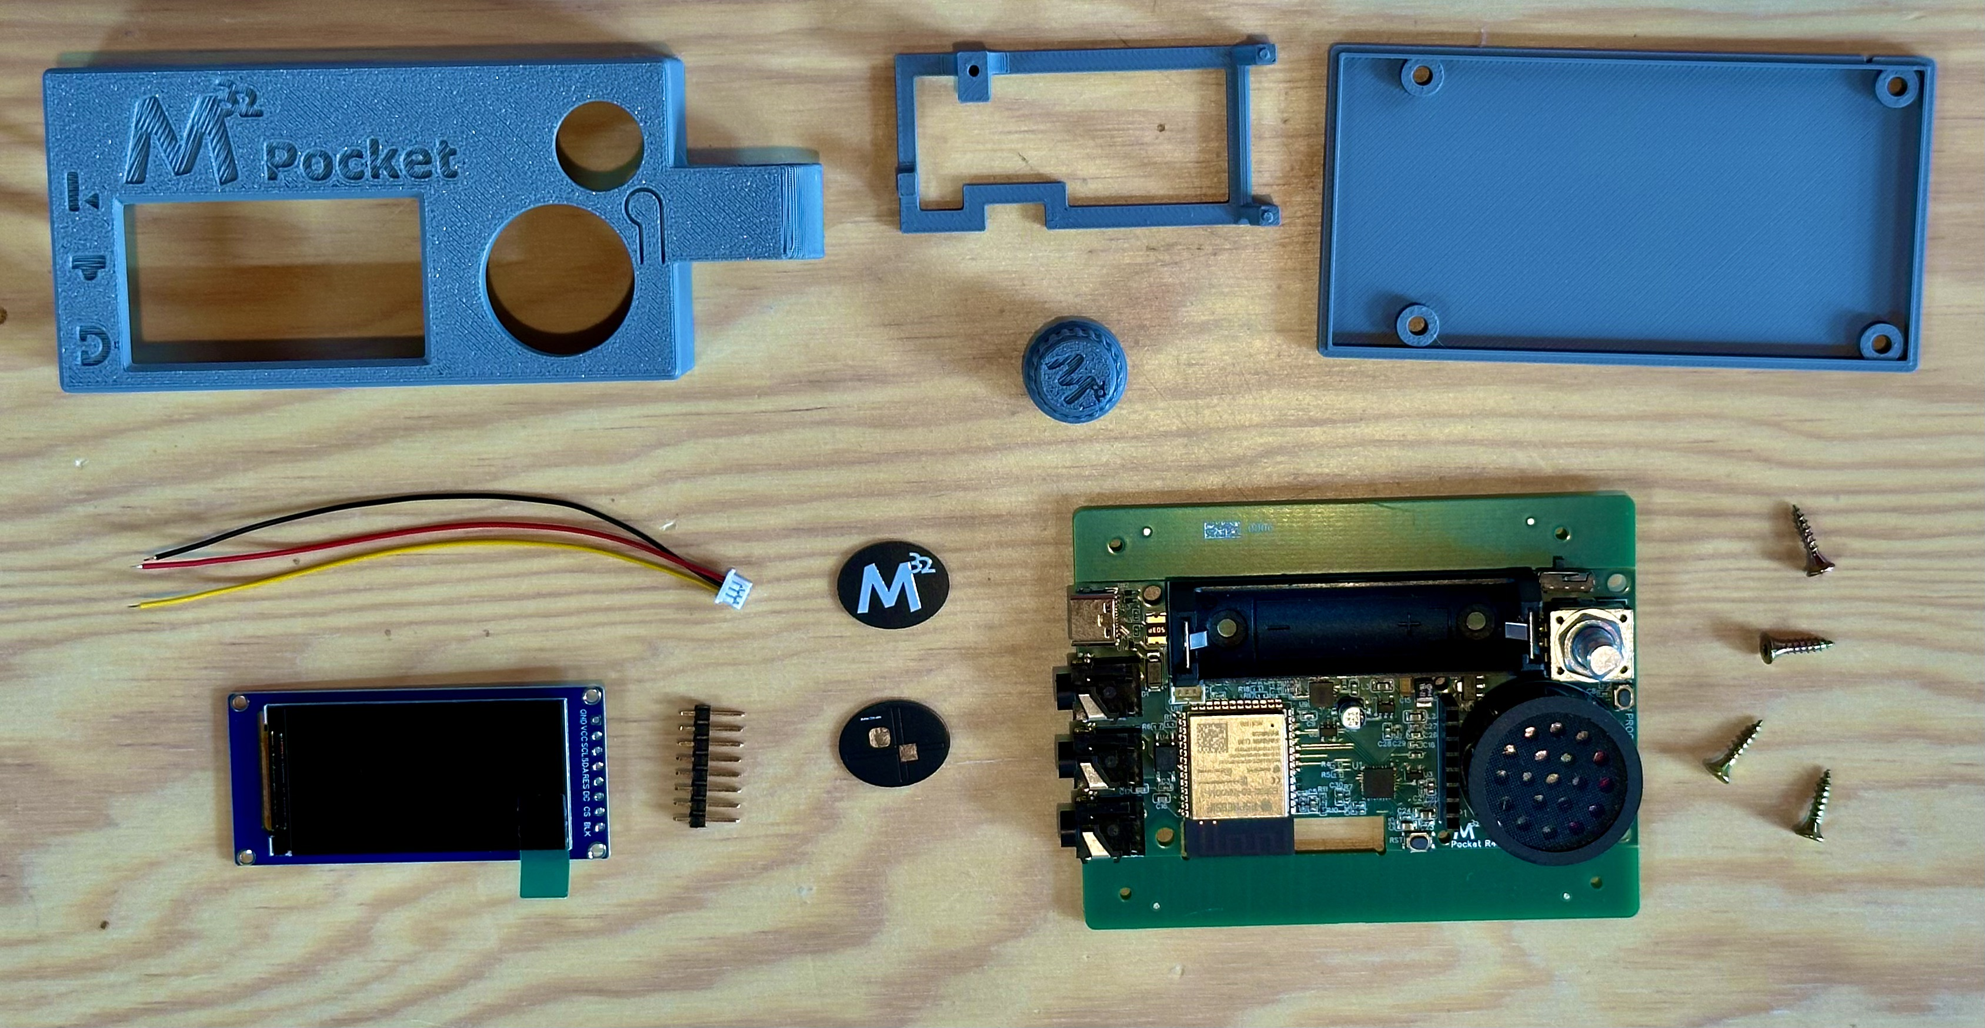
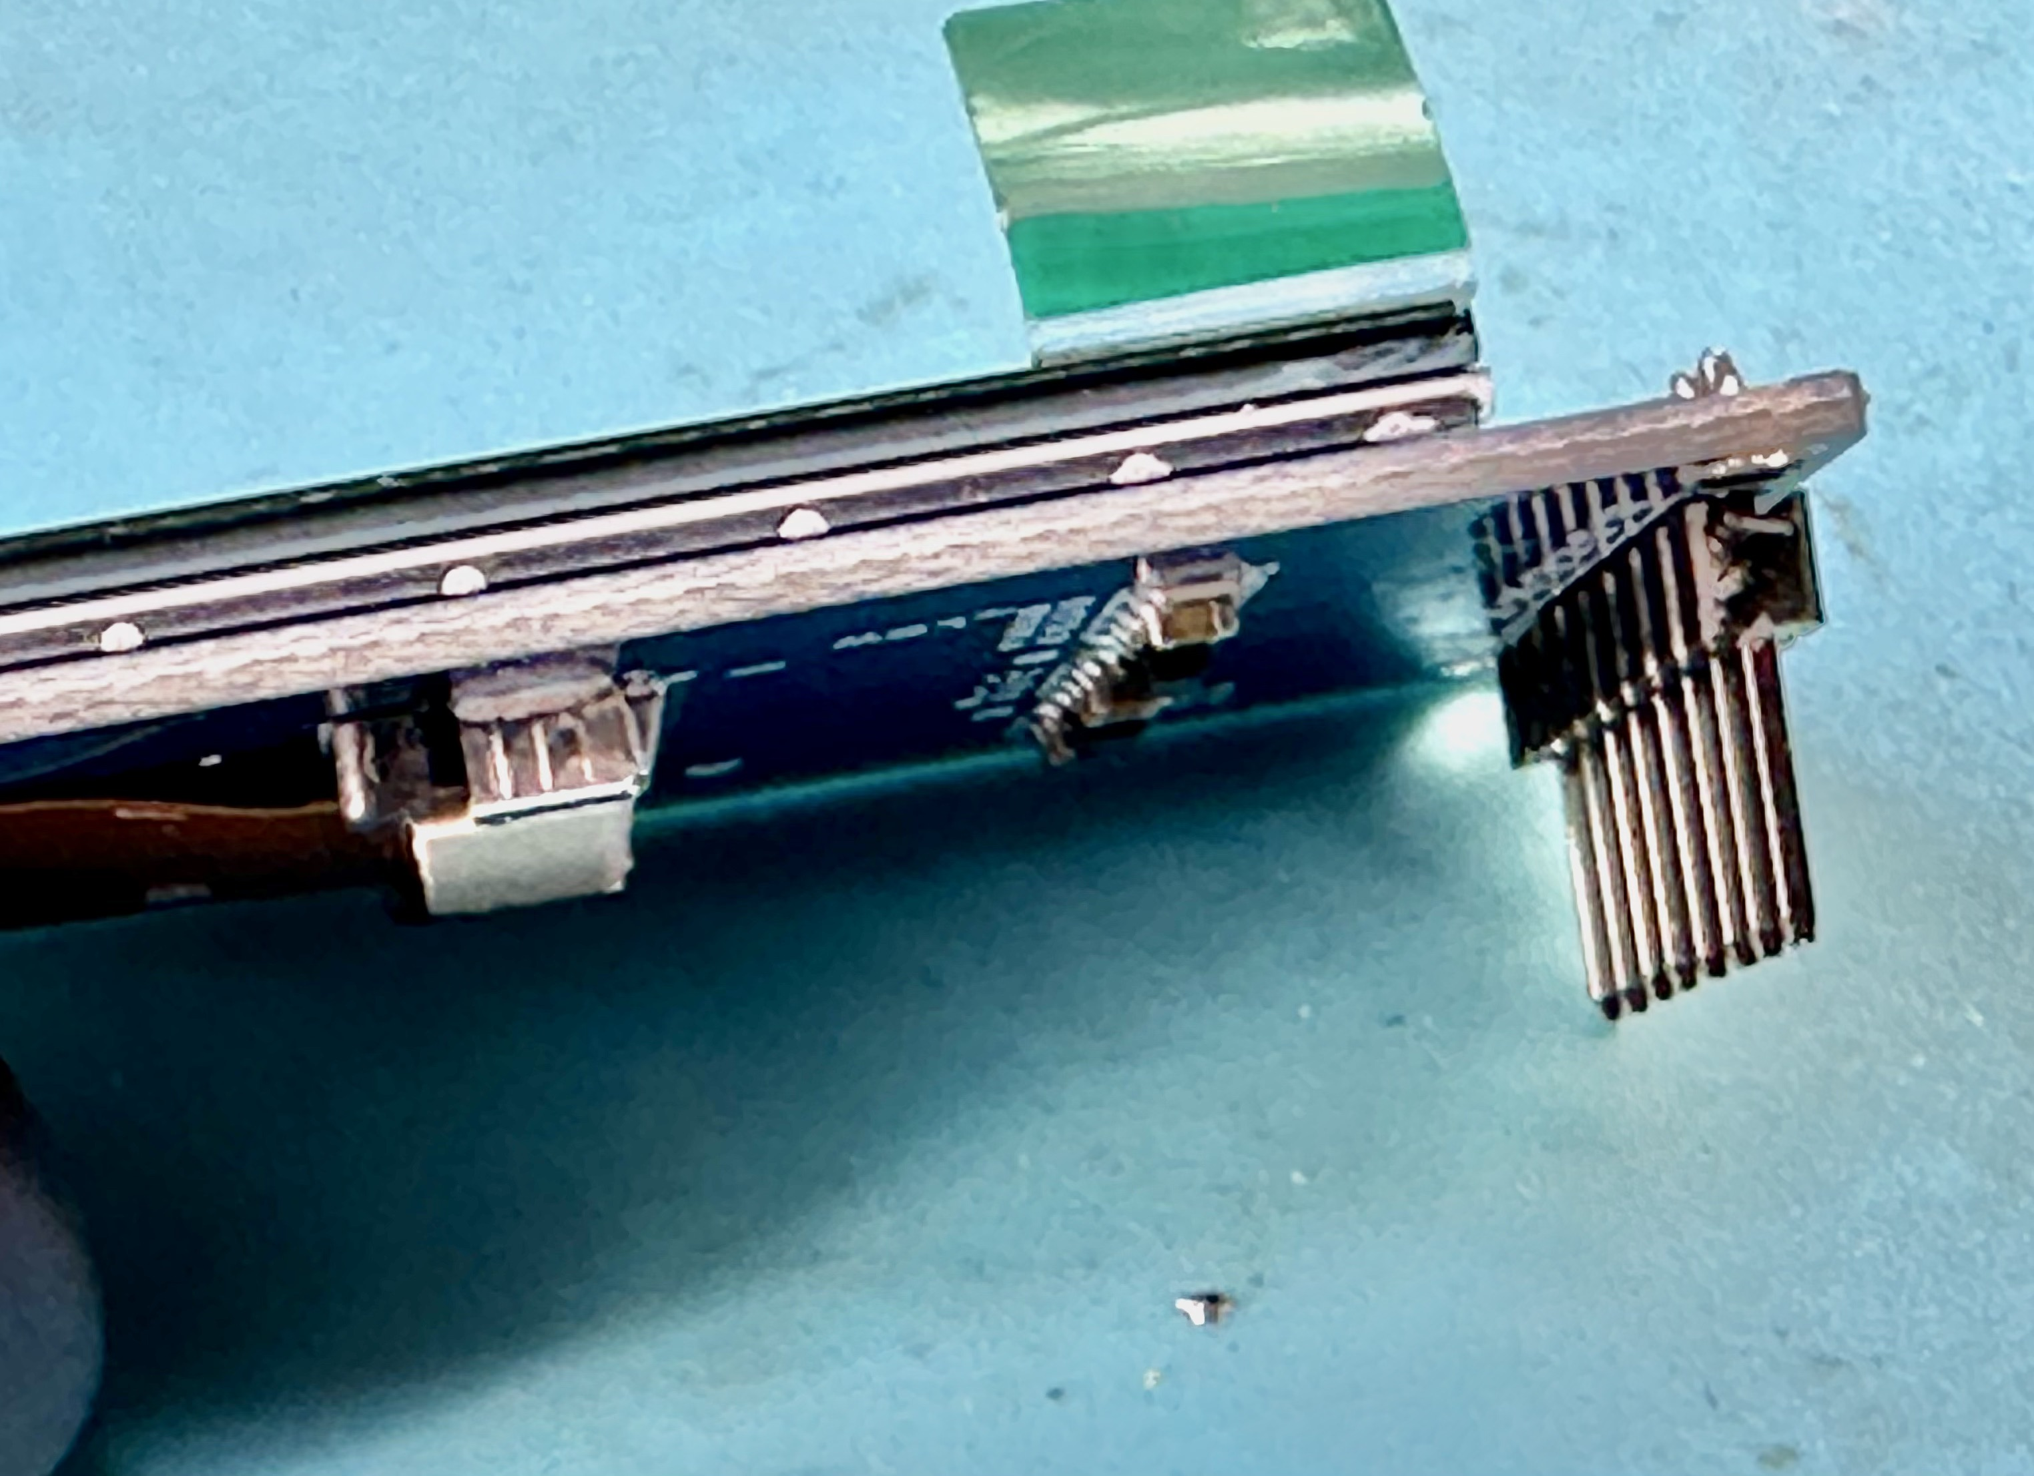
1.1 Solder pin header to display, making sure that the pins are at 90°.

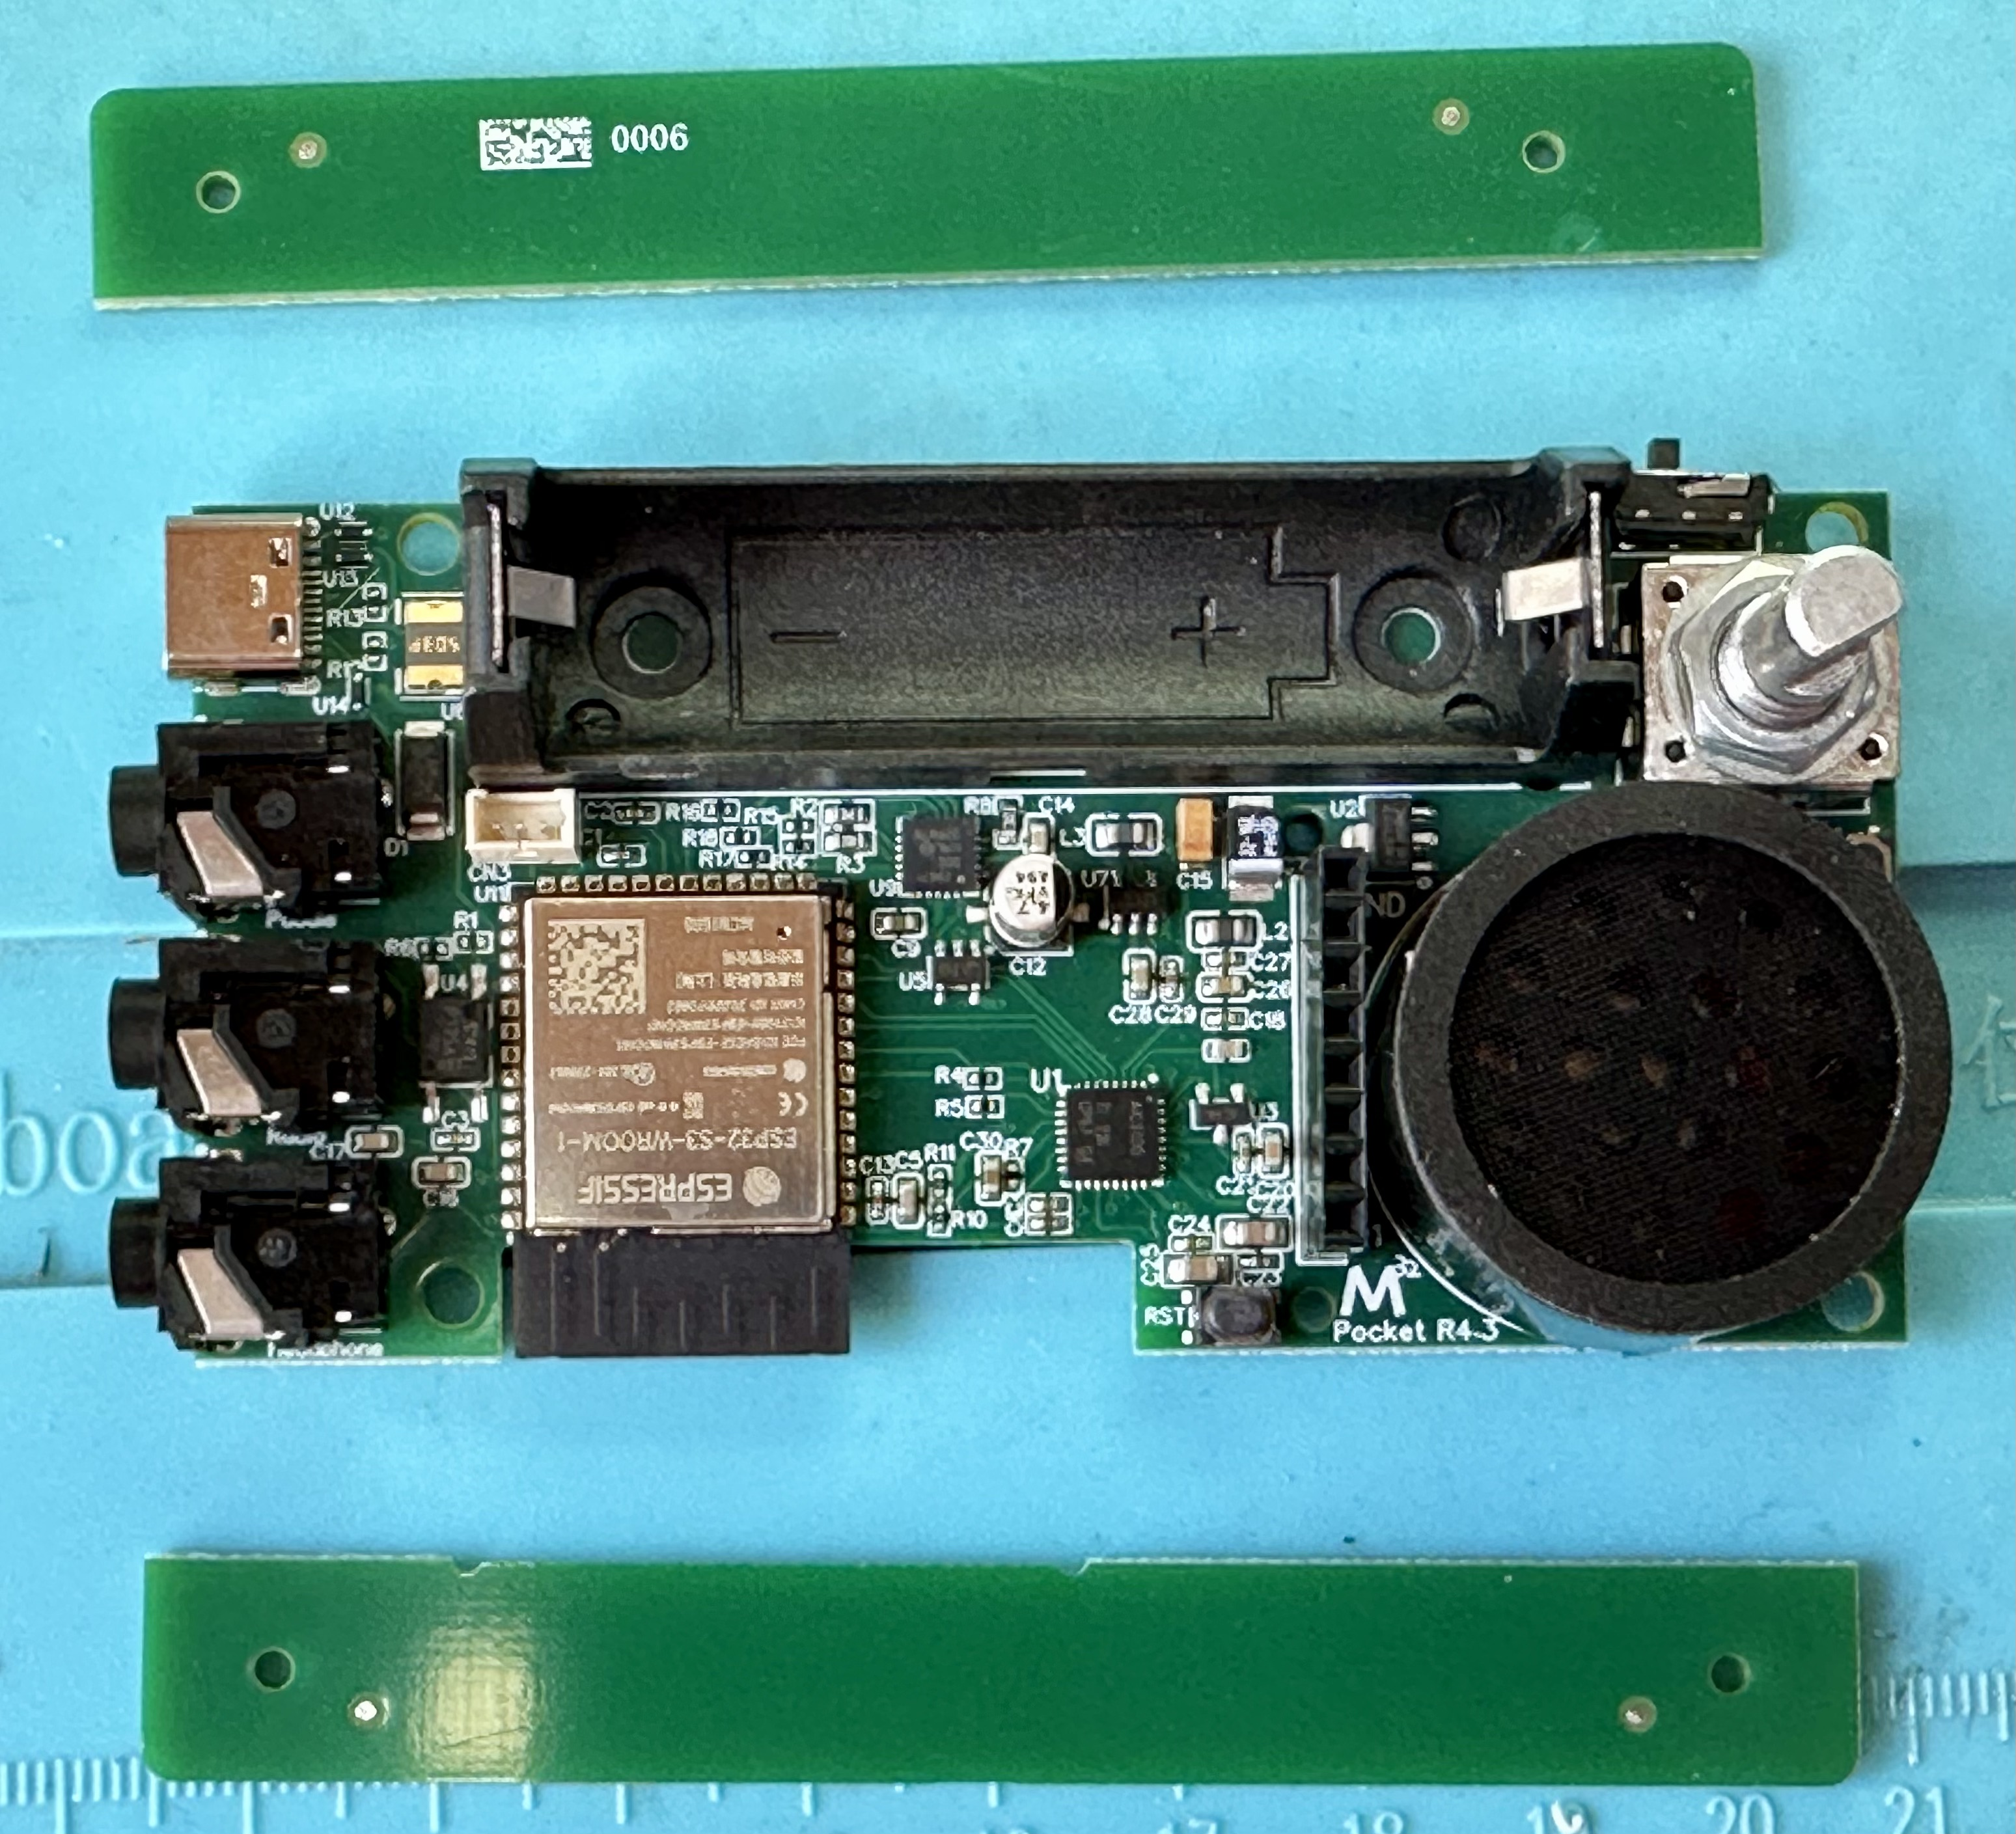
1.2 Break off top and bottom parts of the main PCB – these are there for PCB assembly reasons in the factory and are not being used in the final product.

2. Prepare touch paddles on top part of case
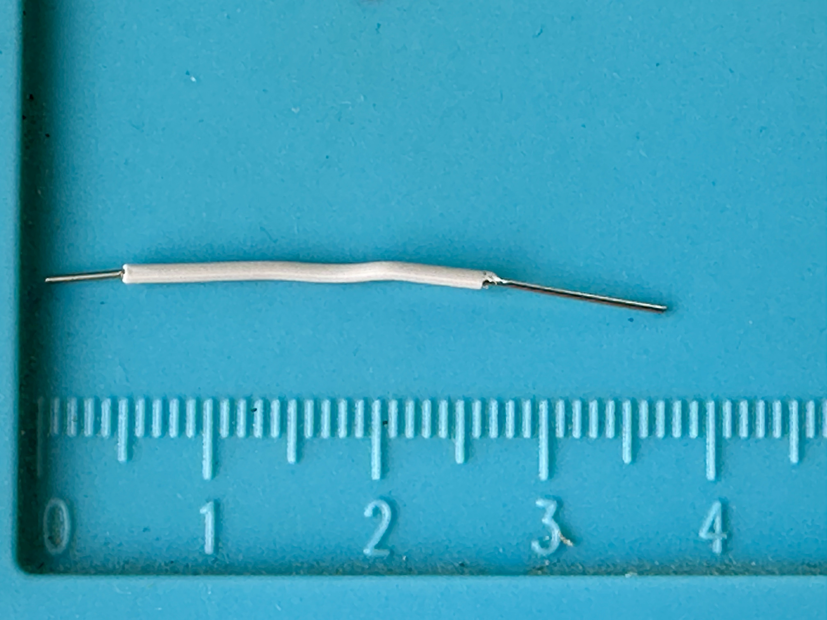
2.1 Prepare a short piece of insulated wire (3.5 – 4cm) – flexible wire is better than a stiff one (I had used a stiff wire for the photos in this guide, and it also works; but a flexible wire is much esier to handle.)
2.2 Remove insulation, short (2 – 3mm) on one end, a bit longer (6 – 7 mm) on the other end.
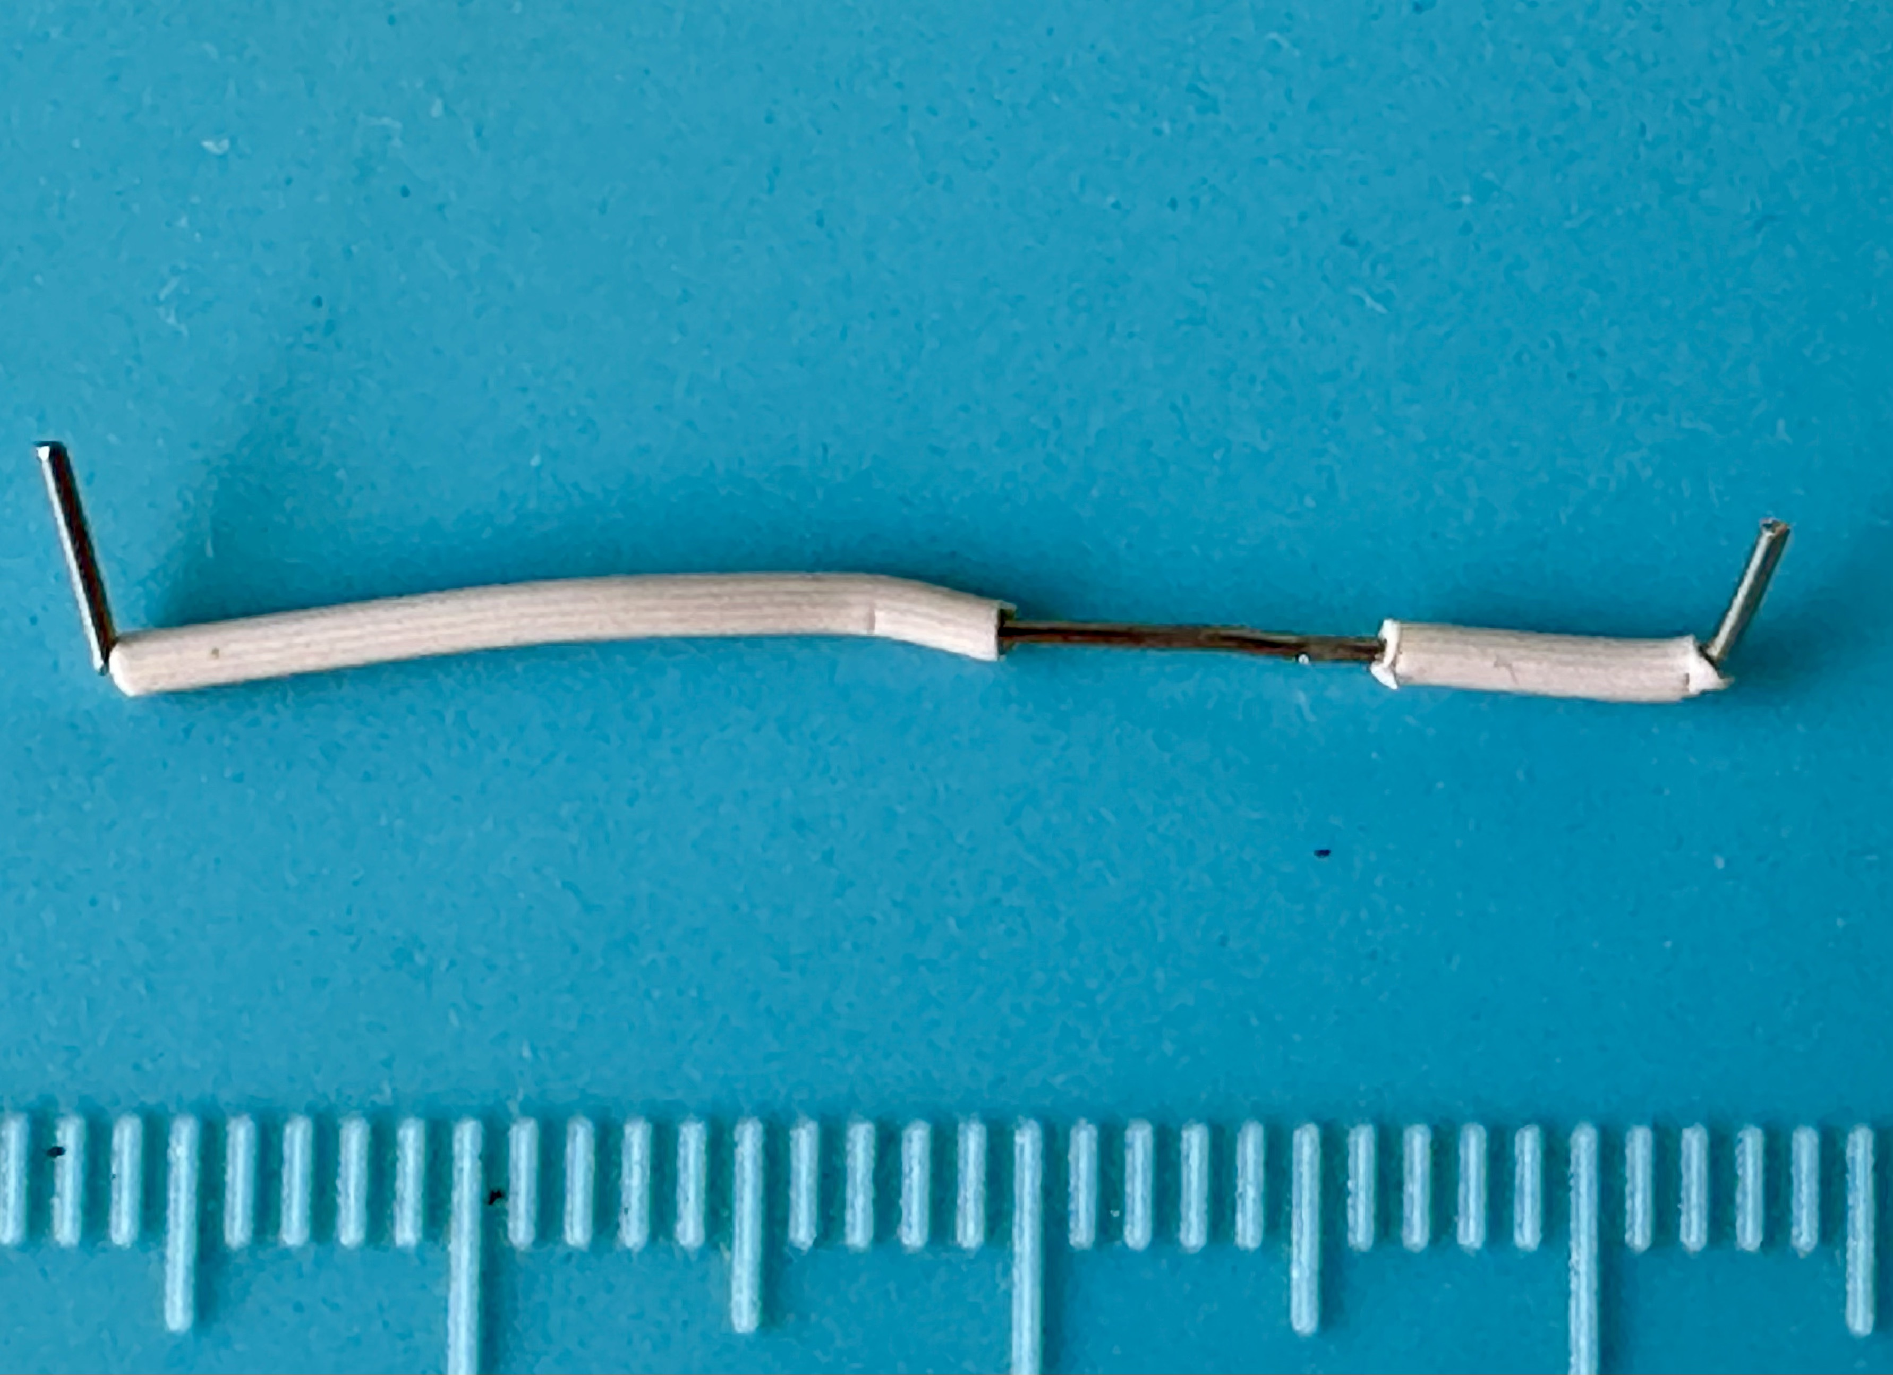
2.3 On one end, carefully cut thru the insulation about 6 mm from its end, and move insulation closer to end of wire, to create a wire that has bare ends about 2mm on each end, and about 3 mm wide along its central part.

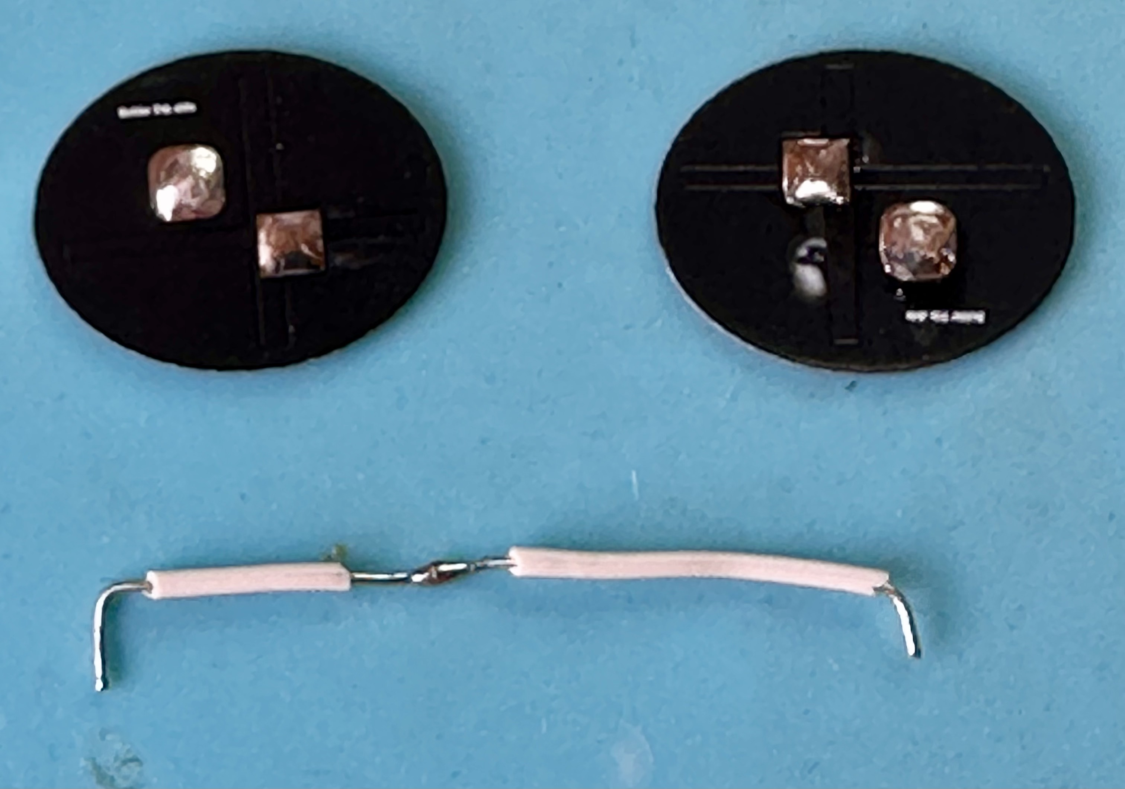
2.4 Put some solder on these three bare parts of the wire, and also on the three ends of the cable assembly with the 3-pole connector, and on each of the solder pads of the elliptical PCBs used as touch surface.

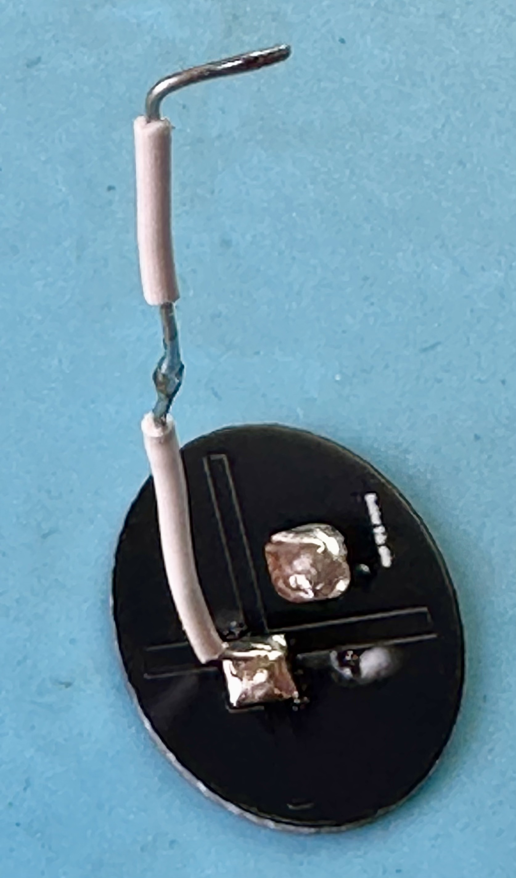
2.5 Solder one end of the wire you prepared to the ground pad on one of the touch pads - the ground pad is the square with sharp corners (the square pad with the rounded corners is the signal pad).

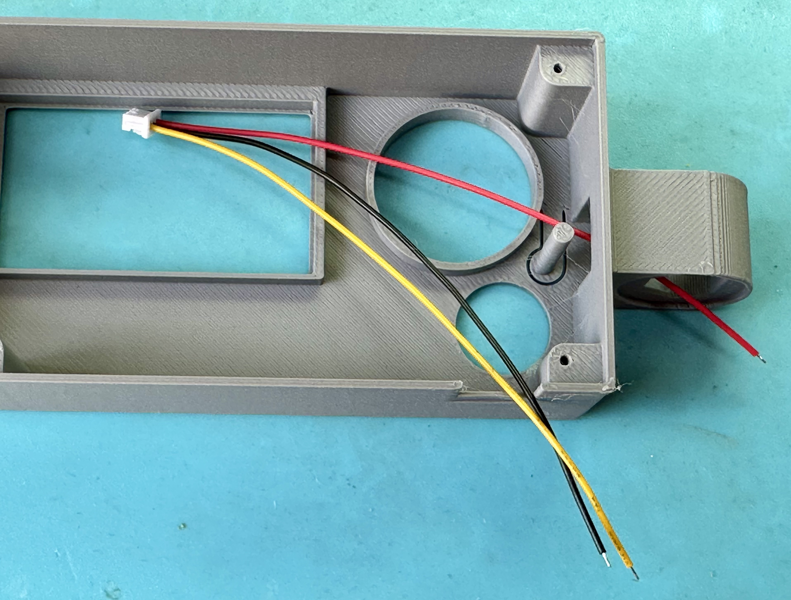
2.6 Route the cable assembly through the touch paddle end of the case, making sure that the red wire goes to the right paddle (the upper one when looking from above at the outside of the case; the lower one when looking at the inside).
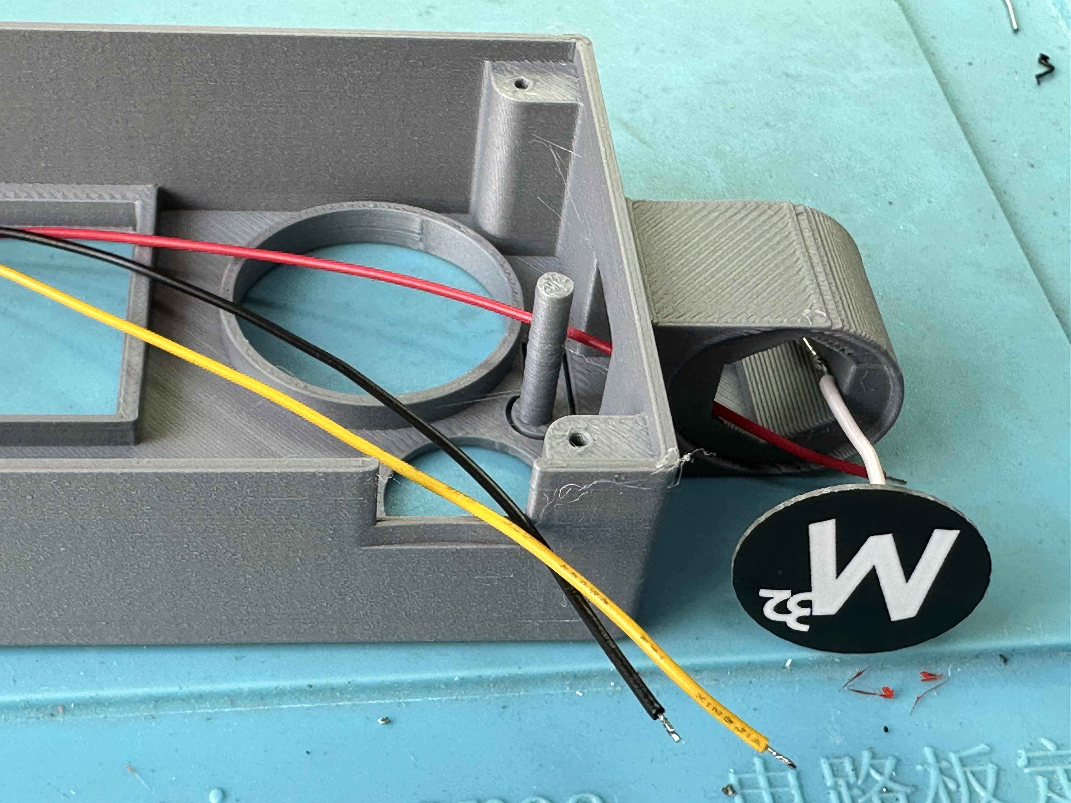
2.7 Solder the red wire to the signal pad on the paddle that already has the short wire connected to the ground pad.

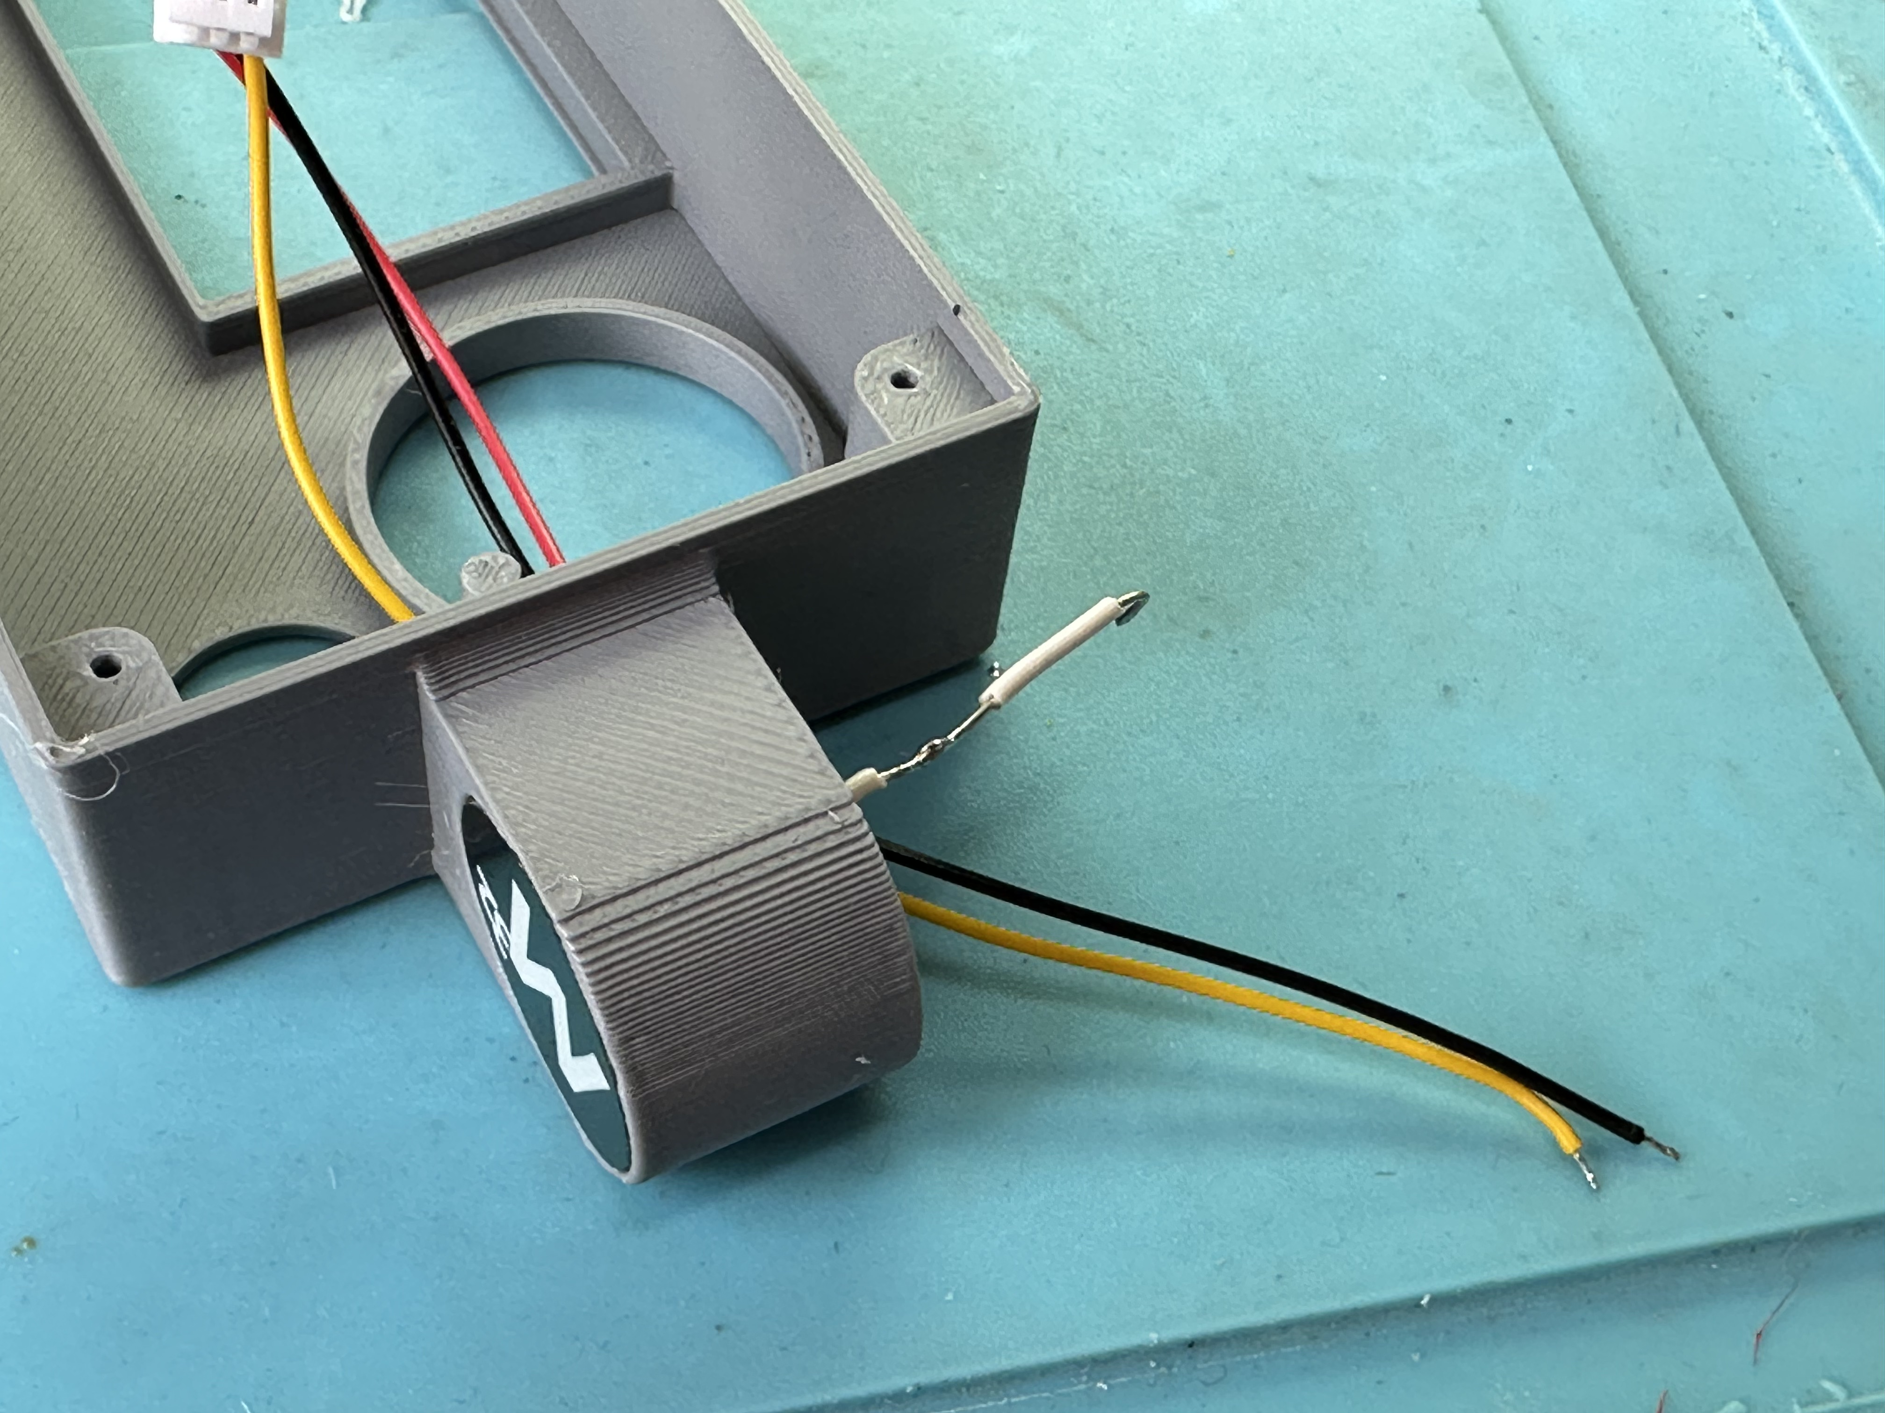
2.8 Move that pad close to its final place on the case, so that the other end of the prepared wire goes through the opening on the other side of the case.

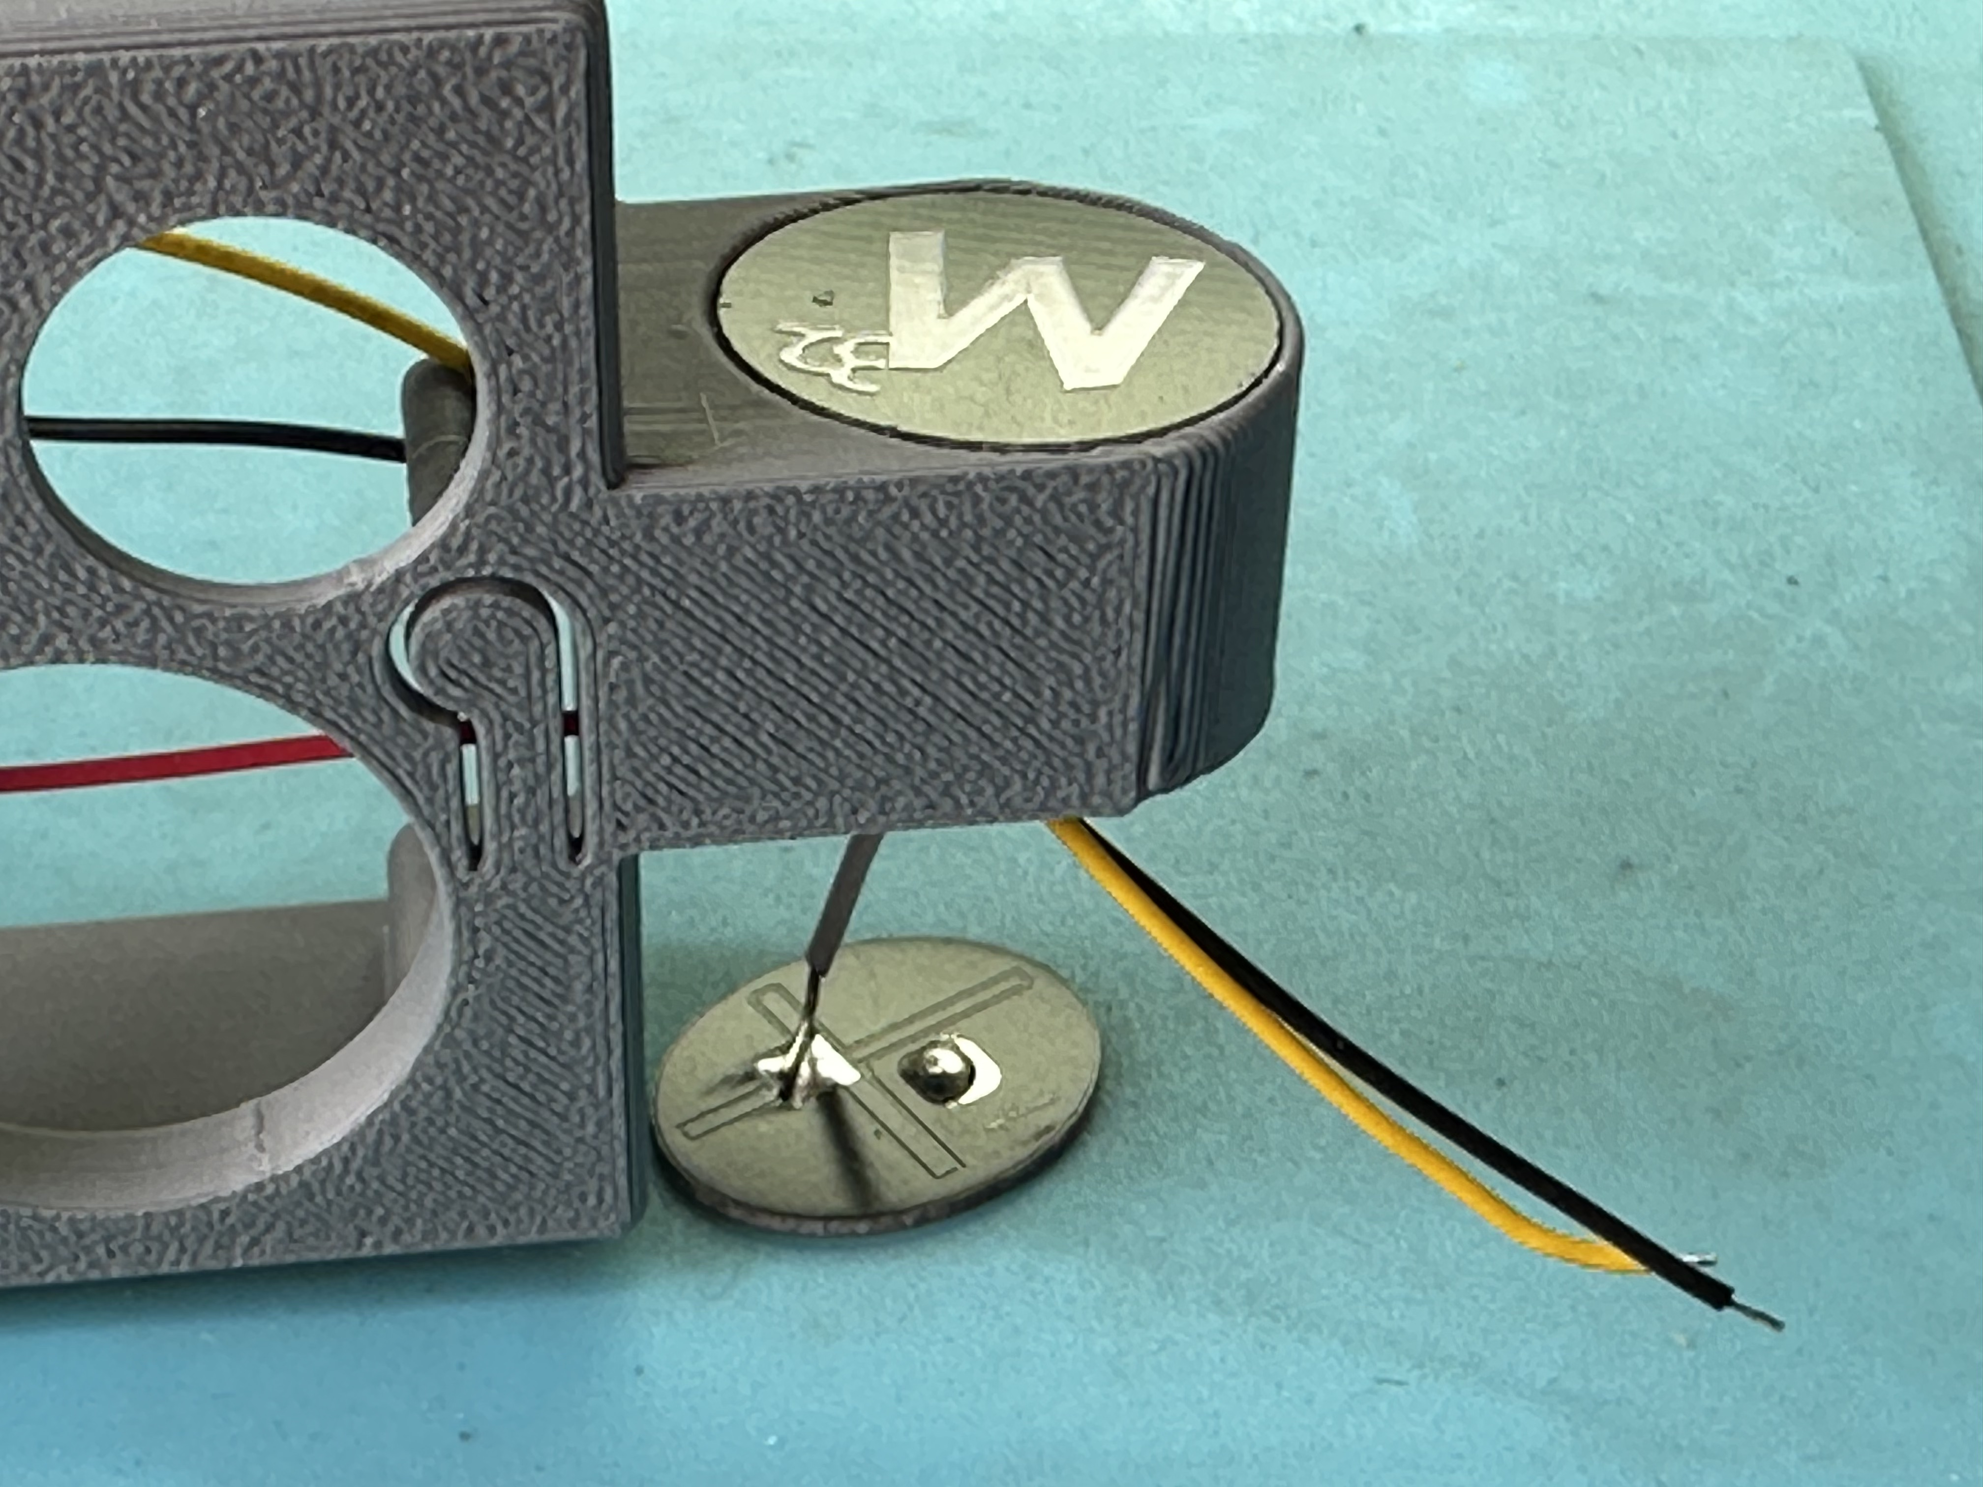
2.9 Solder that wire to the ground pad of the second touch PCB.

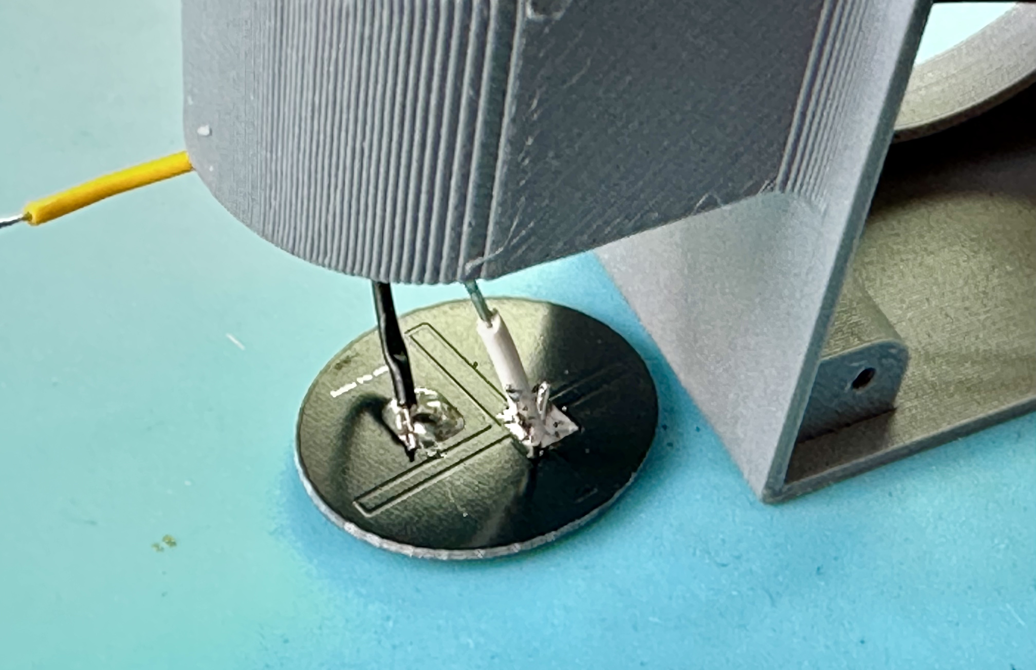
2.10 Solder the black wire from the cable assembly to the signal pad on that PCB.

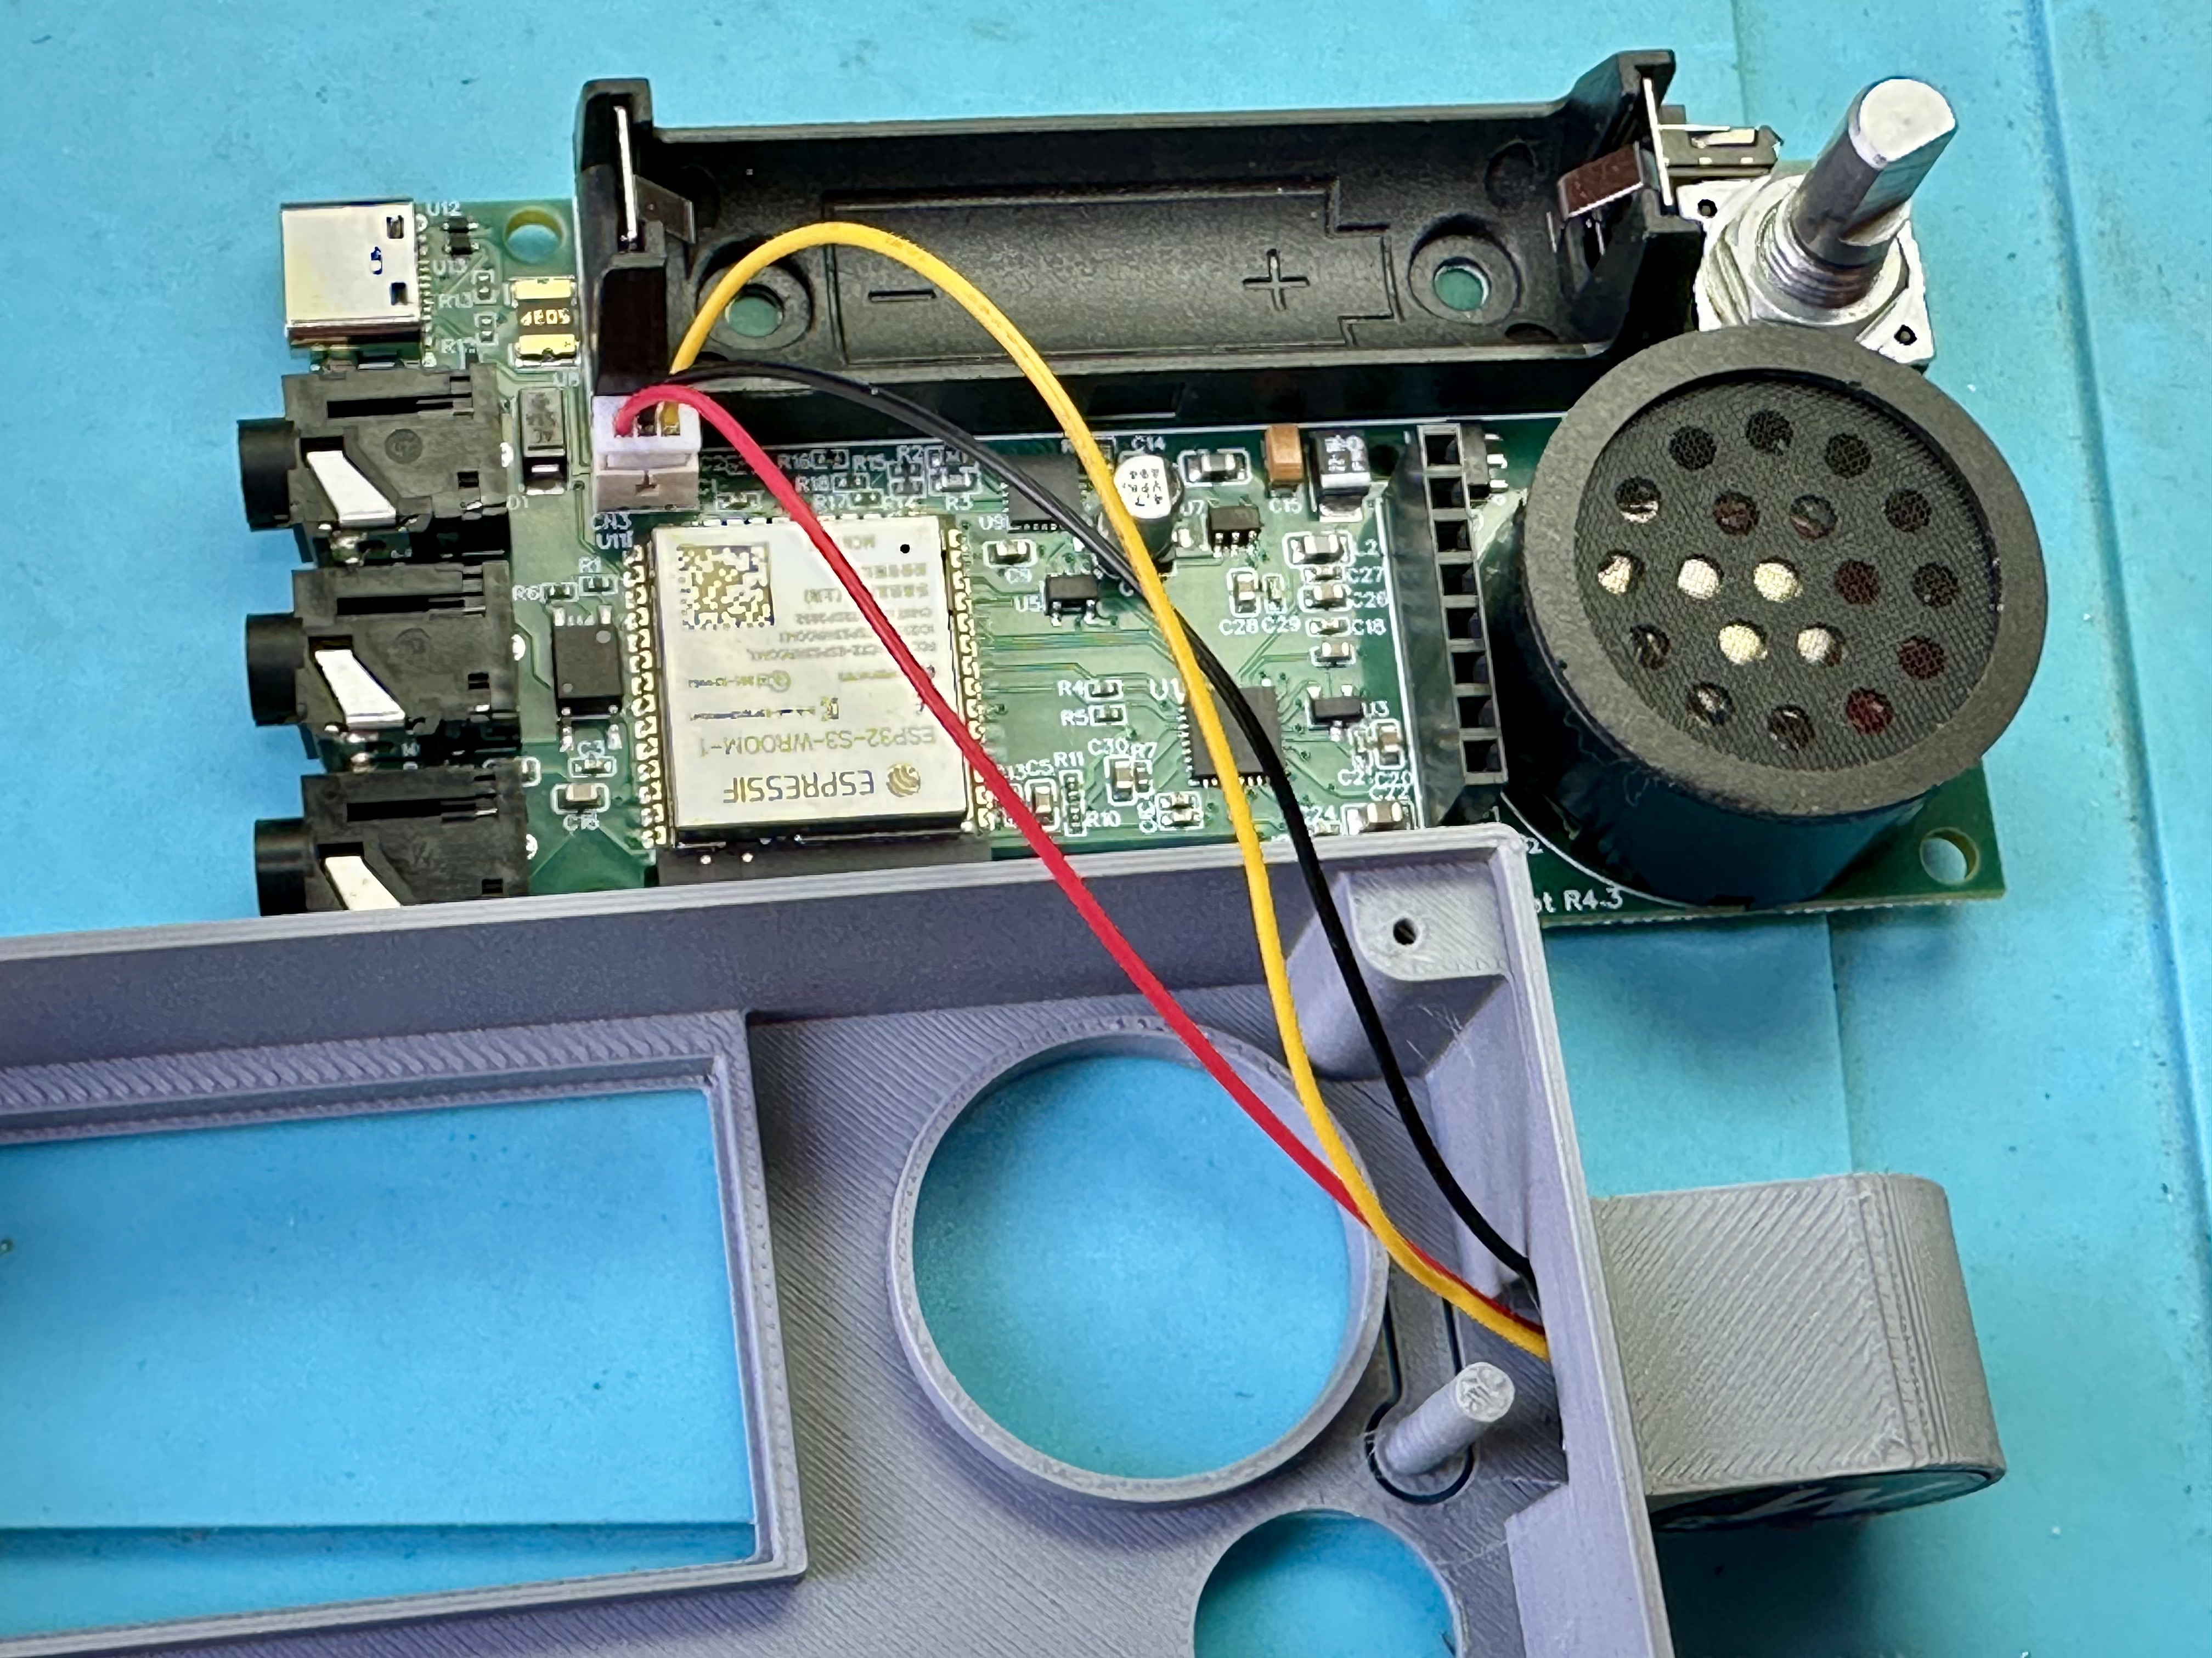
2.11 Solder the yellow wire from the cable assembly to the exposed part in the middle of the wire connecting the two ground pads.
2.12 Carefully pull the cable assembly so that the touch paddles are close to their seatings on the case. With tiny drops of glue fix the touch PCBs into their seatings (gel type glue used in households or model building works best, you can also use cyanacrylate glue. Do not use glue for plastic sometimes used for model building like Revell Contacta - these glues are based on butyl acetate and can only glue plastics, but fail on the PCB of the touch paddles!).
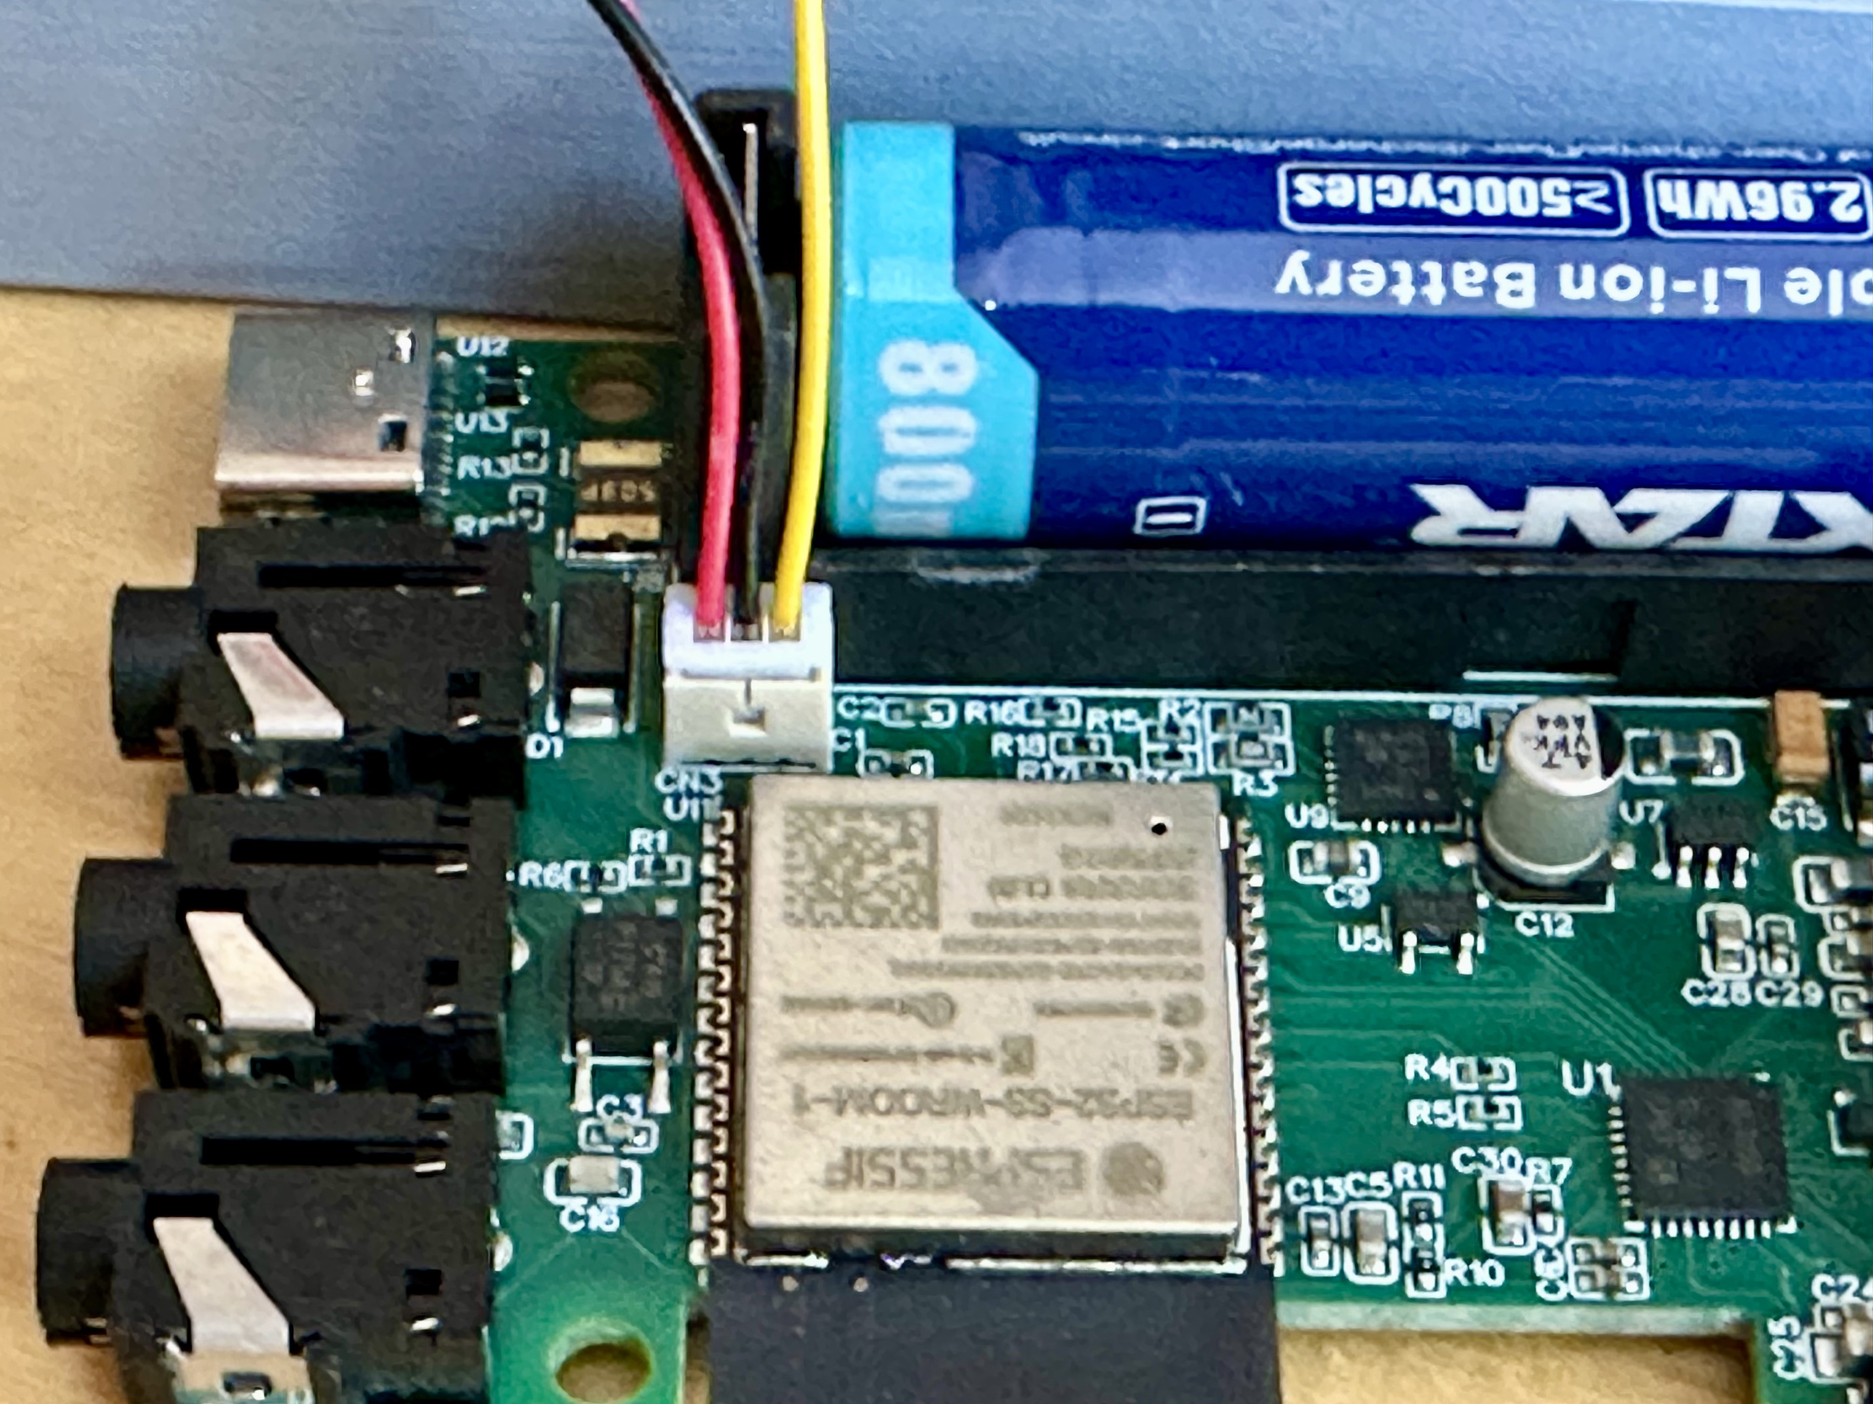
3. Insert the battery into its holder, make sure plus and minus poles are oriented correctly (otherwise you will probably destroy your device!).
Make sure you have the correct type of battery: Single cell LiPo, 3.7 V, protected (better safe than sorry!), 14500 form factor (and make sure it is not too long – some „14500“ cells are much longer than 50 mm – up to about 52 mm is ok for the batter holder), with a button on the plus side (same shape and size as a AA battery, but different voltage of course)!

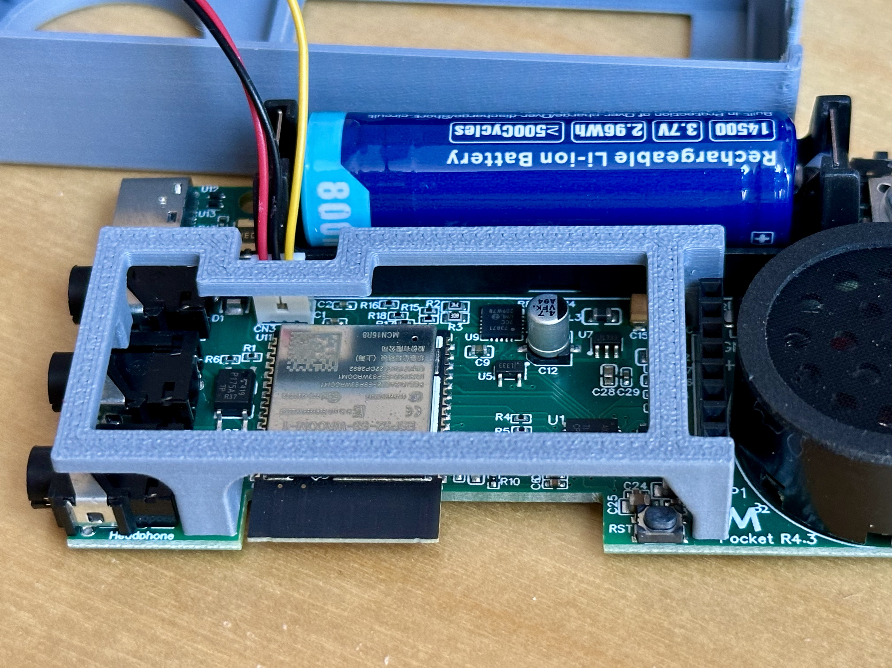
4. Connect the three pole plug of the cable assembly to the socket on the main PCB, making sure you orient the case so that it will easily go over the PCB.

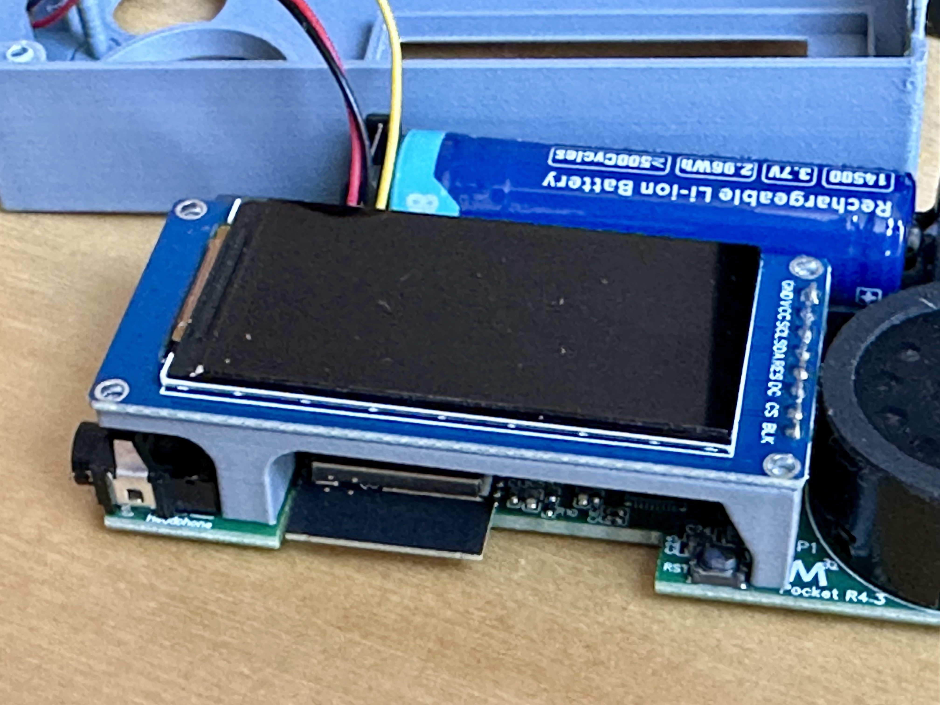
5. Place the plastic display holder on to the main PCB (two tiny pins go into holes near the speaker), and attach the display by pushing the pin-header into the socket on the PCB, so that the display sits flush on the display holder.

5a. You can test the functionality of your device at that stage – switching it on (or connecting it to a USB-C power source) should show a start-up screen and a main menu entry on the display... Pushing the encoder knob when the display shows “CW Keyer” brings you into the keyer, and touching the paddles should generate some sound and characters on the display.
After that test, turn the device off again and complete the final steps:
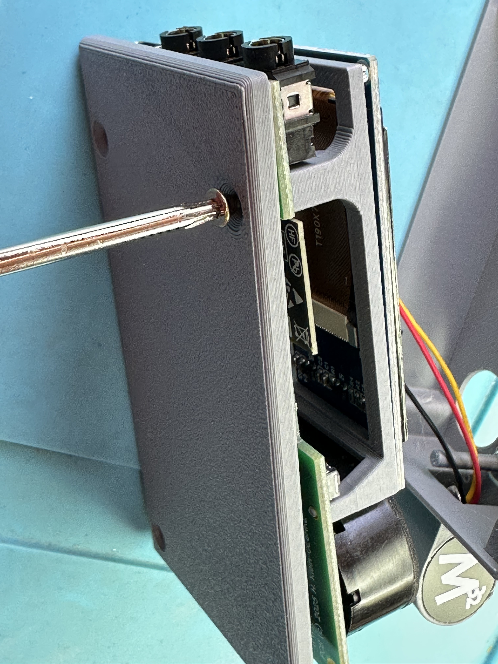
6. Take the bottom of the case, and use one screw to fix the case bottom to the display holder and the main PCB, but do not fully tighten that screw yet.

7. Carefully put the top part of the case over the main PCB, making sure that the wires of the cable assembly are not being squeezed between case and display or case and loudspeaker.

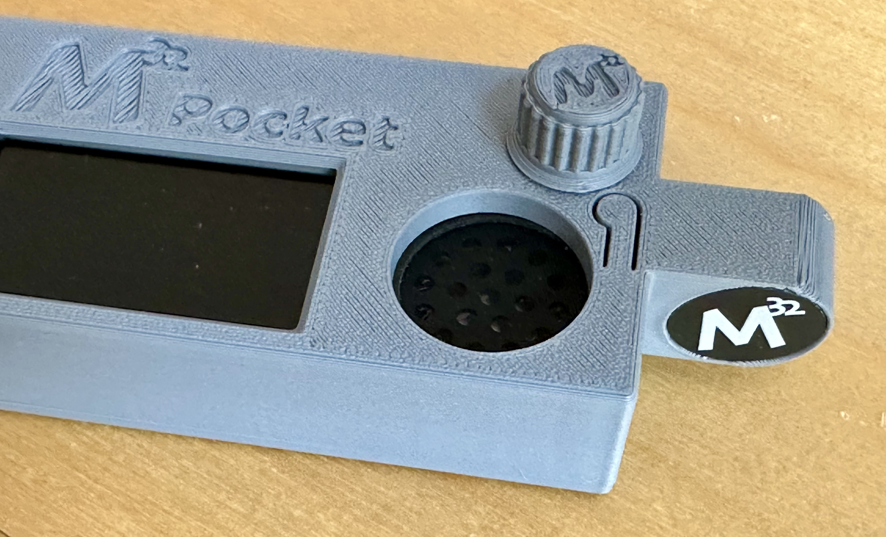
8. Fix the bottom of the case to the top with the three remaining screws. Tighten all 4 screws now, being careful not to tighten them too hard (they are self cutting screws that cut their thread into the plastic of the case – over tightening them ruins these threads).
9. Put the turning knob onto the shaft of the rotary encoder.
Congrats, you M32 Pocket has been assembled completely!

